For the sake of the discussion below, consider the following:
Tetrahedron 1 Tetrahedron 2

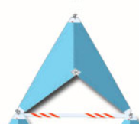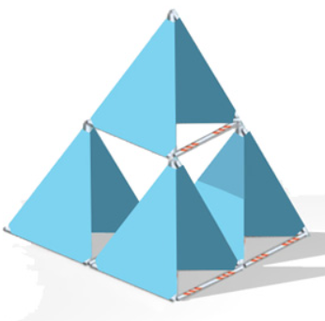

- Compare a face of Tetrahedron 1 with a face of Tetrahedron 2. Describe what you see.

- How do you know that the triangular face of Tetrahedron 1 similar to the triangular face of Tetrahedron 2?

- What are the ratios of edge length and area from Tetrahedron 1 to Tetrahedron 2?

- Make a conjecture about the relationship between the edge length ratio and the area ratio of similar figures.

- What is the volume of Tetrahedron 2 in terms of Tetrahedron 1?

- What is the shape of the open space in Tetrahedron 2? How could we find its volume?

OTHER PRACTICE PROBLEMS:

- Cube A has an edge length of 2 centimeters, and cube B has an edge length of 4 centimeters. Calculate the area of one face, the total surface area, and the volume of each cube. Determine the ratios of edge length, area of one face, surface area, and volume for the two cubes. Explain how the ratios are related.

- Cube C has an edge length of 1.8 meters, and cube D has an edge length of 5.4 meters. Calculate the area of one face, the total surface area, and the volume of each cube. Determine the ratios of edge length, area of one face, surface area, and volume for the two cubes. Explain how the ratios are related.

- The edge length of cube E is 3 inches. The area of one face of cube E is one-half the area of cube F. What is the edge length of cube F? Explain your solution.

- The dimensions of a rectangular prism are 13 cm × 8 cm × 5 cm. Increase each dimension by 50%. How is the volume of the new prism related to the volume of the original prism? Explain your solution.

- Choose a radius for a sphere, and calculate its volume. Then, create a second by doubling the radius. Calculate the volume of the second sphere. Compare the volumes of these two spheres. Does the comparison match your expectation of the ratios?

